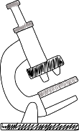
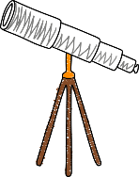
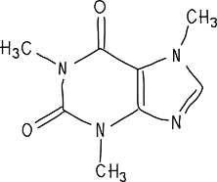

Terms and Conditions

What to create
You should create and submit both of the following:
- A Hero Video: a two-minute video telling the story of an unsung hero of science
- A Team Video: a two-minute video of your team introducing yourselves and answering the questions below.
Your video should be aimed at 12 year-olds so must be engaging and explain ideas clearly, and it should be in English.
You don’t need any fancy equipment – you can just shoot and edit the videos on your phone, or use whatever you have to hand. Search online for free video editing apps to help you.
You can pick whoever you like to be your “unsung hero” – they can be alive or dead, from anywhere in the world. The important thing is that you should be able to explain why you chose them. They should be working or have worked in science, technology, engineering or maths.
The videos should be the work of only the people on the team.
Each video should not be longer than two minutes. If you send us something that is too long, we will ask you to cut it down before we consider it.
Your team video should answer the following questions:
- Who is your unsung hero of science?
- Why did you choose this unsung hero?
- Why do you think they are not well known?
- Why do you think they should be better known?
- What’s your favourite fact you learned while making this video?

Who can enter
- Anyone aged 16-18 on 31st August 2024
- You may enter as an individual or in teams of two or three people
- You can come from any background and do not have to be at school or college
- We particularly welcome teams from backgrounds that are diverse or generally under-represented in science / STEM
- There is no entry fee for this competition
- No-one may enter more than once per year

How to enter
You must submit your entries no later than Tuesday 16th April 2024. To submit your entry, complete the online entry form: https://app.onlinesurveys.jisc.ac.uk/s/oxford/unsung-heroes-of-science-2024
This will ask you to give us the web address of somewhere we can watch your video, e.g. YouTube or Vimeo. On both of these sites, you can create a free account, upload your video and tell us the web address for the video. You can also make your video “unlisted” if you don’t want anyone else to see it.
If your video is shortlisted, we will ask you to send us the video files by Monday 13th May, so that we can upload them all to our channel and share them all together, including sending them to the judges.

Judging
There will be two categories of judging: UK (for all UK-based entrants) and International (for all international entrants).
Both videos you submit will be considered in judging, but priority will be given to the scientist video. The content and appeal of the video is more important than the “production value” – you don’t need to have any fancy equipment or snazzy editing tools.
A panel including communication professionals will shortlist the videos. The shortlisted videos will then be judged by a scientist who will select the winner. The panel’s and judge’s decisions are final.
The shortlisted videos will be made available publicly. The video that has been most viewed (discounting any paid-for views or promotion/advertising) by 10th June 2024 will win the ‘popular vote’.

The prize
The creators of all the shortlisted videos in the UK category will be invited to a celebration event and prizegiving in Oxford. All shortlisted videos will be published and promoted on the Hertford College website and social media. A further top prize for the UK winner(s) will be announced in due course. The prizes are not transferable, and we reserve the right to alter the prizes and events at any time.

Video rights
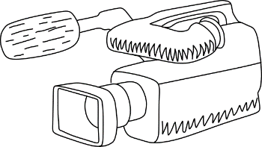
The videos you submit may be used by Hertford College as we see fit. This use may include, but is not limited to, sharing on College and University websites and social media channels, publishing on YouTube, re-editing of material to appropriate formats, and creation of classroom resources around the videos. As far as possible, Hertford College will acknowledge the creation of the original video by the team members in all uses. Please ensure you include appropriate credits or references in your video if you use images etc. that you do not own the copyright for. (For an example of how you might do this, look at the last few seconds of the 2022 competition launch video.) By submitting your videos, you agree to be bound by these conditions.

General conditions
Hertford College shall have the right, at its sole discretion and at any time, to change or modify these terms and conditions. In this scenario, entrants will be informed as soon as possible. Hertford College also reserves the right to cancel the competition if circumstances arise outside of its control.

