The Chapel at Hertford College

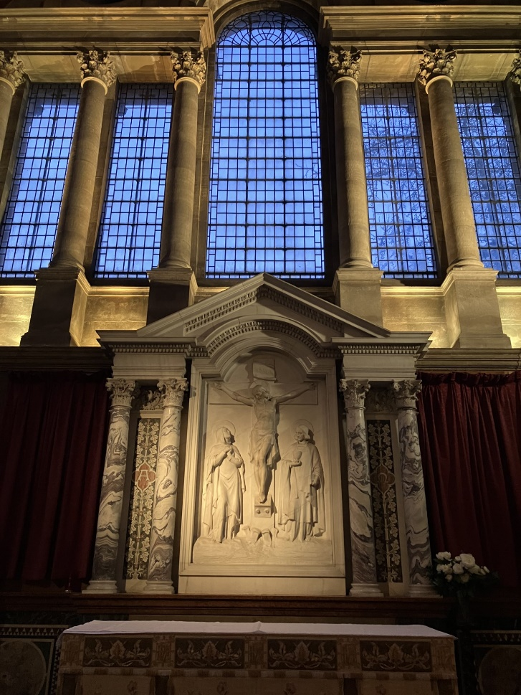

Hilary Term 2024

Sunday Evensong at 5:45pm Living Wisely

1st Week 14th January Carols for Epiphany

2nd Week 21st January 'Extinction and the Call to Remembrance' Dr Celia Deane-Drummond, Director of the Laudato Si Research Institute & Senior Researcher in Theology, Campion Hall.

3rd Week 28th January Presentation of Christ in the Temple The Chaplain

4th Week 4th February Choosing wisely The Chaplain

5th Week 11th February Wisdom for Lent The Chaplain

6th Week 18th February Wisdom through humility Professor Holly Ordway, Cardinal Francis George Professor of Faith and Culture at the Word on Fire Institute. Tolkien Scholar.

7th Week 25th February Thinking wisely The Rev’d Gemma Birt. Formerly Litigation Lawyer, currently Curate, St John the Evangelist, East Dulwich.

8th Week 3rd March Wisely to Easter The Rev’d Dr Jenni Williams. Formerly Tutor in Old Testament, currently Vicar of St Matthew and St Luke, Oxford.

Thursdays at 6pm Half an hour of reflection and prayer

18th January Compline
25th January Communion
1st February Compline
8th February Communion
15th February Compline
22nd February Communion
29th February Compline
7th March Communion

Special Events
Sunday 21st January, 10am, MacBride University Sermon
Monday 29th January, 6pm, Roman Catholic Mass followed by a free supper. Contact Jenny Grehan-Bradley for further details.
Ash Wednesday 14th February, 6pm, Holy Communion

And…
For information about the Christian Union, contact Enkhtamir Erdenebulgan.
For information on Eco Church, contact Nell Miles

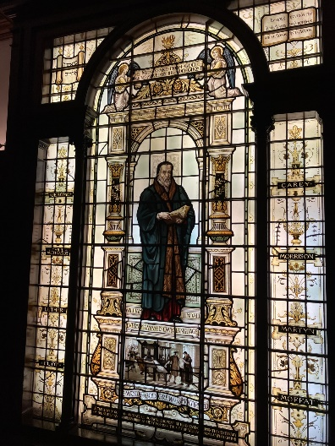
The Chapel is kept open and everyone is welcome to use it as a quiet space. All are equally welcome to our services.
During their time in Oxford many people from all faiths and none explore what they believe and why. If ever a cup of coffee seemed good, please do not hesitate to ask. Likewise please ask if you would like contacts with any of the faith groups across the university.
And, if ever there is anything on your mind at all, or you simply want a break from work and a chat, please email me on chaplain@hertford.ox.ac.uk

Best wishes for the term ahead

Anthony Buckley

Our Charities for the term are Oxford Winter Night Shelter, providing accommodation for the homeless January to March, and Mission Aviation Fellowship, providing help to isolated communities across the world. Our collections will be divided between them.

