

Hertford College, University of Oxford Alternative Prospectus

Hello
Welcome to our Alternative Prospectus! Produced for you by current Hertford students, we hope these pages will dispel many myths surrounding Oxford and encourage you to apply here. We’d love to give you a flavour of what living and studying at "the friendly college with the bridge" is really like. We hope you can see that Hertford has a home for you no matter what your background. We're still proud to have been in the first ground-breaking group of all-male colleges to admit women in the 1970s, and we've been encouraging applicants from under-represented backgrounds to join us as Hertfordians for over 50 years. One of the things our community prides itself on today is being particularly progressive and inclusive.
Hertford really is a wonderful place to be, and we would love to have you here with us! From sport to music, and from economics to student politics, our college is a vibrant community of endless variety. Several of the write-ups in here come from JCR reps - that means they're current students who have been elected to a position on the JCR committee (or Junior Common Room) to represent their fellow students. The JCR is both a physical common room where we can hang out *and* the name given to the whole body of undergraduates at Hertford.
Anyway, there's far too much to say in just a few pages so do come and visit us if you can, either in person or online. We hope you enjoy reading our Alternative Prospectus as much as we enjoyed creating it!
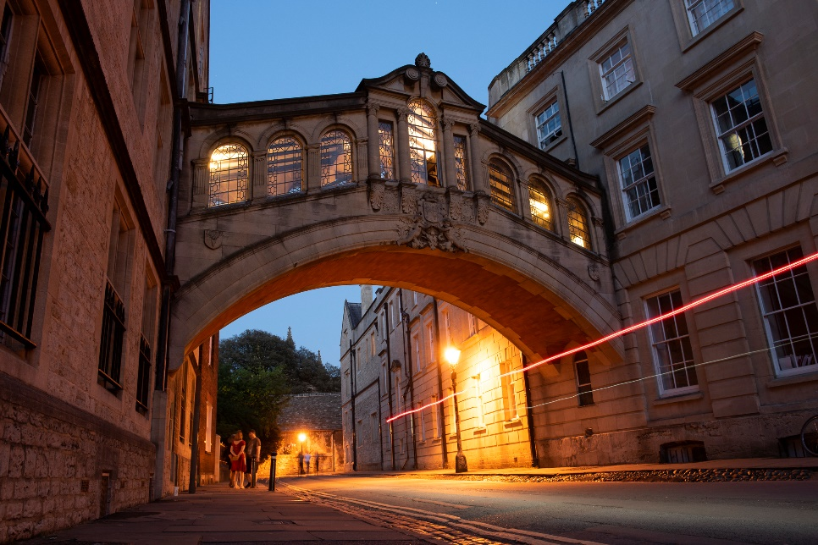
Saida, Editor & JCR Access Officer (English, 2nd year)

The Bridge of Sighs

Our college's most famous landmark, the star of a million postcards and tourist selfies. It's names after a medieval bridge in Venice but - whisper it - doesn't look anything like the original!

Small college, big heart
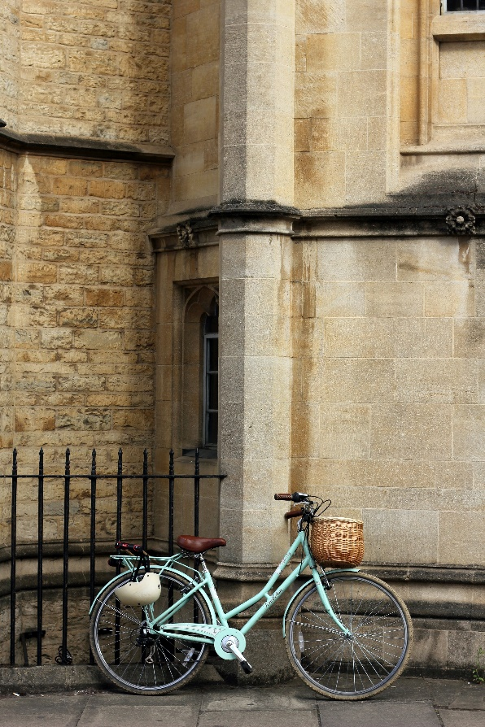
We say 'small' but Hertford is actually in the top third of Oxford colleges when it comes to student numbers. With about 120 of us in a year group, that means it's incredibly easy to meet people and find friends without feeling lost. The thing that's small-ish is the physical college, mainly due to the fact that it's squashed into the medieval centre of Oxford. Pluses to this include being able to reach the main University library (the Bodleian) in about 30 seconds flat, and always bumping into people to have a chat with - whether it's the rest of your friends sat on a bench in the main quad, someone you can catch up with over lunch, or even your tutor if you've got a burning question about that essay! Hertford doesn't have a lot of green space but we are allowed to lounge around on the main lawn during the summer, which isn't something you can do in most colleges. The small main site is made up for by our off-site accommodation, meaning that everyone can have a college-owned room if they want one.

Politics & Economics Society
We host a number of exciting talks with influential speakers every term, from the MP David Lammy and former Number 10 communications director Alastair Campbell, to journalists like Owen Jones and Krishnan Guru-Murthy. The talks are followed by dinners which Hertford students can attend, giving us the amazing opportunity to question the speaker and carry on the debate! We’ re also planning to arrange more events with former Hertford students involved in the political and economic worlds to give us an insight into future careers.

Oxford’s biggest music society
We're one of the most musical colleges in Oxford, with the largest and most active college music society. Hertford College Music Society (HCMS) is run by students and organises the Chapel choir alongside three instrumental ensembles - the orchestra, chamber ensemble and jazz band! We have regular lunchtime recitals and a big concert every term, so there's loads to get involved with, even if you aren't studying music. As well as this, there are plenty of social events and dinners throughout the year, which are always a lot of fun and a great chance to meet new people. We're also lucky to have a music practice room and two beautiful grand pianos in college which we can play!

Simpkin

Simpkin is our not-so-cuddly college cat. His favourite place to hang out is your laptop keyboard about half an hour before your essay is due... There's been a Simpkin at Hertford since the 1970s and the current one is the fourth to hold this great office. Named in his honour - and always featuring him on the cover - we also have a termly comedy magazine edited by students and covering the more memorable events and mishaps of the term!

Charity
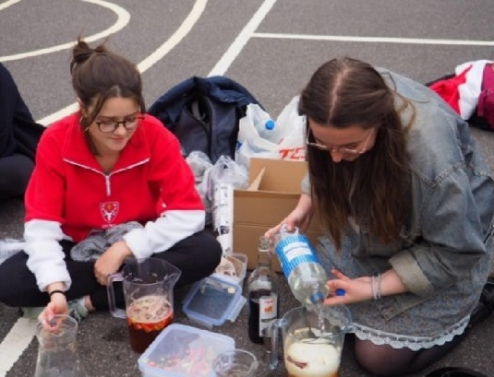
In this photo, we're selling drinks at the football vs netball match to raise money for H4H or Hertford for the Homeless. We're a student-run action group which pools together the college's resources to provide short-term aid to the homeless community in Oxford, as well as supporting larger organisations focussed on rehabilitation with funding and volunteers. As you can see, we do lots of fundraising through events like charity tournaments and even cheese and wine nights!

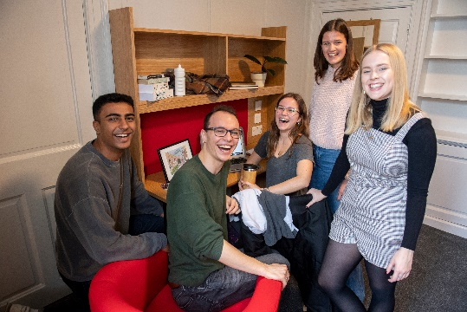
Guaranteed accommodation

It's really great that Hertford can provide housing for every single year of your degree. All the freshers get to live on the main college site (in New Buildings or Holywell Quad) in the centre of Oxford, with almost everything you could possibly need for Oxford life within a five-minute walk. Just over the road is the main Bodleian Library with literally millions of books, and we're just a stone's throw away from beautiful buildings, uni departments, parks and sports pitches, pubs and clubs, supermarkets, and loads of shops, both big and small. The rooms in Holywell Quad have been refurbished this year (2020) and they're *so nice* - the rest of us who've missed out are v jealous!
All the rooms at Hertford cost the same price, but they're also all a little bit different. Whether you live in a 17th-century house, a Victorian villa or purpose-built student halls, you'll always have a comfortable room with Wi-Fi and weekly cleaning. After first year, students enter a random ‘ballot’ (sometimes with a group of friends) to decide on the order in which people get to choose their rooms, which means that the process is as fair as it can be. The range of properties owned by the college means that there are lots of different accommodation options to suit your lifestyle after first year.
Down by the River Thames in South Oxford, about a 15-minute walk from college, are purpose-built halls with en-suites and great shared kitchens. There's also another dining hall down here where chef Nigel and his team whip up some of the best food in Oxford. In the opposite direction, Hertford owns several big Victorian houses in North Oxford, about a 20-minute walk or 10-minute cycle from college. These houses have been split up into individual rooms with shared bathrooms and kitchens, so they make a great base for a group of mates. North Oxford means cute shops and pubs, the University Parks for sport and walks, and most of the science departments (making these houses even more convenient for scientists than the main college site in town!). For your final year you'll get first pick in the ballot system, meaning that you can nab a great room in the location you like best. Wherever you live in Hertford, you'll have a community of fellow students on your doorstep and know you're paying a fair price - with one of the cheapest college rents in Oxford, Hertford is hard to beat.
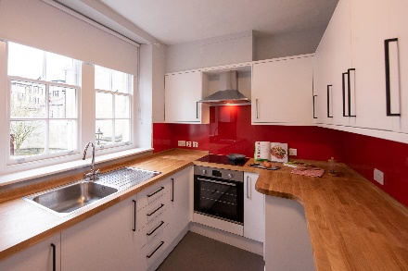
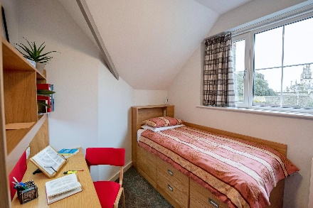
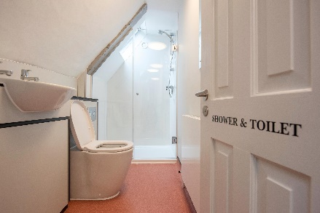
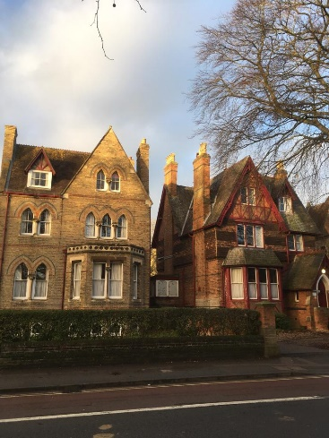
Find this year's rent prices at www.hertford.ox.ac.uk/finance
Shiny new first-year bedroom, shared bathroom and kitchen in Holywell Quad.
North Oxford townhouses.
Purpose-built halls on the River Thames.
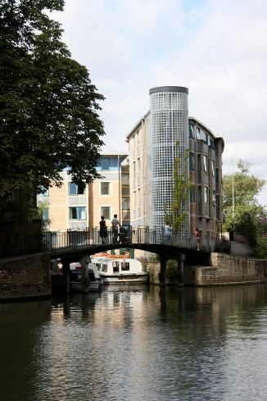

Proof that a college kitchen is big enough to make a full-on roast!

What’s a bop?
A bop is a 'Big Organised Party' apparently... essentially a bop is a fancy dress party for everyone in college - we hire out a club in town just for Hertford (even the DJs are students) and award prizes for the best costumes. Bops are organised by the college JCR Entz Reps (which is short for 'entertainment'), who also turn their hands to running open mic nights, pub quizzes and movie nights, catering for all your alcoholic and non-alcoholic socialising needs! We might have lots of work to do, but Oxford students definitely enjoy a good night out, whether that's a party or a board game session. There's never any pressure to go out if you don't want to, and you'll always find someone in college who shares your interests.

An open mic night down the bar.

HartFest
See what we did there? HartFest is Hertford's very own arts festival which takes place every year during the summer term. Running through the week, the festival is packed with cool activities, performances and workshops. In recent years, we've enjoyed an open-air cinema in the middle of the quad, a college play, a DJing workshop, a pop-up Pimm's bar, and even a group portraiture class with the Principal as our model! And not forgetting the Music Society's jazz band, a regular feature (often accompanied with cocktails) of HartFest. It's organised by students and there's always loads to get involved in, so HartFest really is a highlight of the Hertford year.
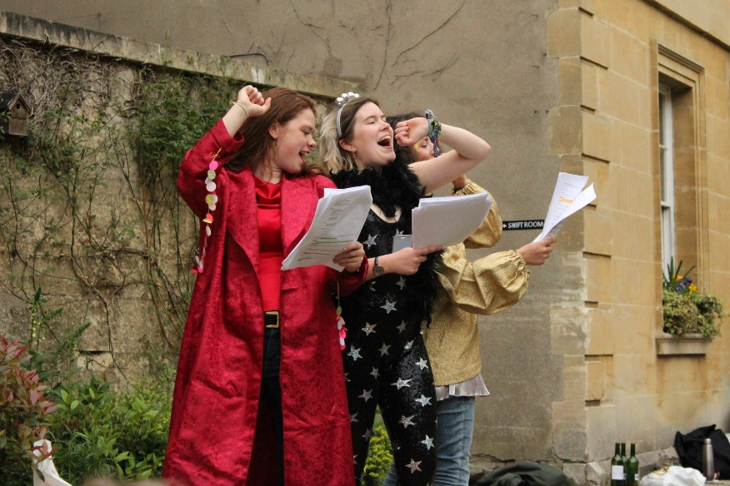
David, JCR Entz Rep (Philosophy, Politics & Economics, 1st year)
‘Mamma Mia: Hert We Go Again’ (we make no apologies for our dreadful puns).

Fear the deer!
This is what we shout at opposing teams, referencing the fact that our college crest is a friendly fearsome dear! Sport at Hertford is a huge part of the college community: whether you’re a sportsperson yourself, or you just enjoy supporting on the sidelines, there is something for everyone. It's all quite informal and, with a thriving social scene too, Hertford sport is a great way to make friends. We have teams for badminton, basketball, cricket, cycling, darts, football, hockey, lacrosse, netball, rounders, rowing, rugby, squash, tennis and ultimate frisbee, to name a few! All our college sports are incredibly inclusive - players of any ability, gender or background can be involved in whatever they like. Whether you play regularly to a high standard, fancy picking up a new hobby, or just need someone to motivate you to put your trainers on, Hertford is the place to be! Our on-site gym has treadmills, bikes, fly machines, rowing machines and a comprehensive free weights section with squat and bench racks. The gym's a relaxed space and a great bonus that not many colleges are lucky enough to have. Hertford also provides some financial aid for those high-flying athletes who wish to play at University level. We’re extremely proud of sport at Hertford for being so accessible and so much fun!
Sofia, JCR Sports Officer (Medicine, 2nd year)


Eating & drinking at Hertford
The main college dining hall, pictured here, offers three meals a day during the week (with breakfast staying open until 10am!) and brunch being served at the weekend. If you’re living in South Oxford accommodation, there’s a second dining room at Warnock House which serves breakfast and dinner every weekday. Warnock food is known for being absolutely delicious with extra large portions. The menus are posted daily so you know what’s on offer. The Head Chef Carl and Nigel in South Oxford cook amazing food and can cater for loads of dietary requirements. They’ re also super open to receiving any feedback, which the JCR Food & Housing Officer (me!) collects and reports back on every week. Hall always has a vegetarian and vegan option at lunch and dinner, and every Thursday lunch is exclusively vegetarian or vegan (honestly so good!) so we can all do our bit for the planet. All of the chicken and lamb served in Hall is halal, making it easy to accommodate a halal diet too. At lunch you can either have a hot meal, jacket potato, or just grab a panini and coffee from our DTB café. For something a bit fancier, formal dining nights are hosted twice a week, on Thursdays and Sundays, with a special guest night formal twice a term when the boat really gets pushed out. Formals are optional three course meals served at the table and the food is amazing. Even better, they cost under £10!
Lots of students use formals to celebrate special occasions, such as birthdays, and we also use them for other special events, such as sports awards, Halfway-Hall (to celebrate second years being halfway through their degree), Christmas and other cultural and religious festivals.
Food at Hertford works on a top-up system, so if you’d rather not eat in college you don’t have to pay anything! Every time you want to eat in Hall, Warnock or the DTB café you simply scan your student card. Most students eat their meals in the college dining halls, making it a really social space, but nearly every accommodation building has a kitchen so you can cook for yourself instead. College really cares about the sustainability of the food. Simon, the Head of Catering, has worked really hard with his suppliers to ensure that the packaging of food is as minimal and recyclable as possible and any leftovers get composted. In addition, the vast majority of the catering staff work directly for the college, meaning they get paid the Living Wage. When you eat Hertford food you can be sure it’s well made, healthy, ethically sourced and delicious!
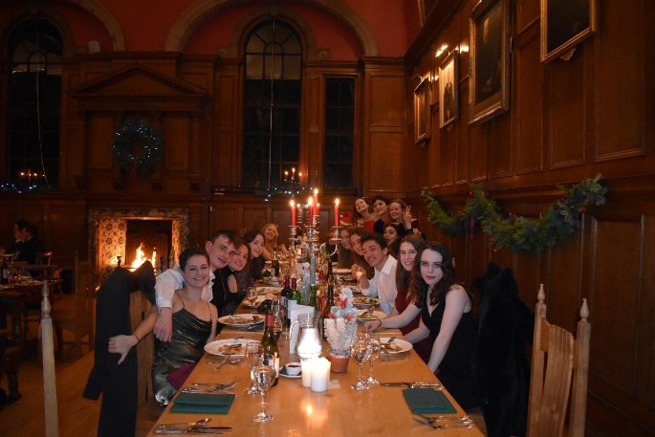
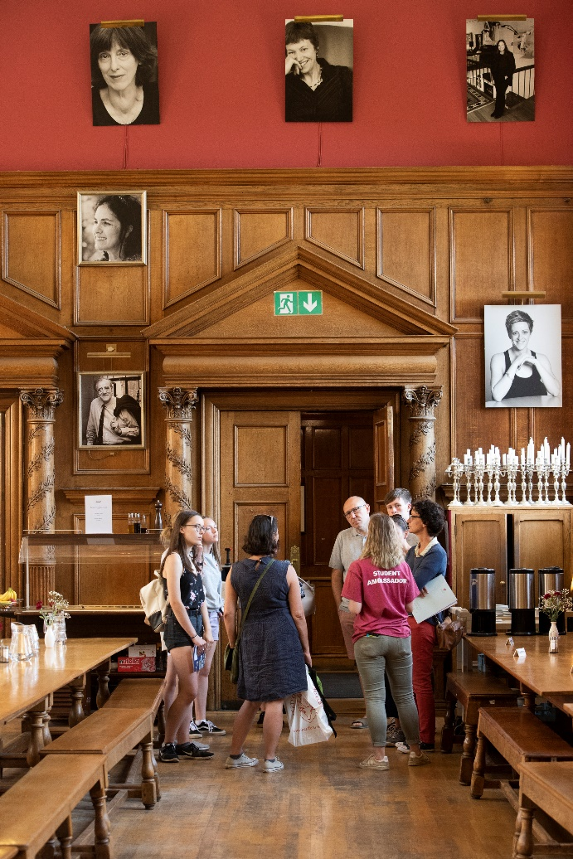
Matilda, JCR Food & Housing Officer (Philosophy, Politics & Economics, 2nd year)
Christmas formal dinner in hall (with the real fire on!).

DTB
Most people don’ t know why we call our college bar DTB, but the reason is because it's in the basement of our New Buildings Quad so if you want to visit you literally have to go 'down the bar'. It's a characterful underground cavern, boasting five distinct rooms to suit any occasion. When you walk down the stairs you’ll find two rooms on the right (the sports rooms), fully equipped with booths, sofas and tables as well as a darts board and a games machine which prove very popular on sports night! To the left of the stairs you’ll find the main bar area where you can nab yourself one of our iconic college drinks - a 'pango' or, if you’re brave, a 'mazza'. If you follow through you’ll find another room decorated with ‘permanently borrowed’ street signs from around Oxford… no one really knows how or when these were acquired. At the back we have the biggest room with lots of seating and a TV, great for watching all the big games on.
Whether you're there to chill with pals or for predrinks before heading out, there's always a great atmosphere. Drinks DTB are far cheaper than all the local pubs and bars, though if that is your scene we’re only minutes away from the Kings Arms and Turf Tavern (widely regarded as the prettiest pub in Oxford) plus many others. Since last year, we have the DTB Café too – in the daytime our lively bar is transformed into a quiet and convenient place to grab a coffee and snack and get down to work… or just chat with mates! The special thing about our bar is the wide range of events that happen there, getting the whole college involved whether or not they're there to drink. We've got charity 'pub' quizzes, open mic nights for music and comedy, and parties aplenty, so head on DTB.
By Jaya (English, 1st year)

Money
The financial burdens of starting uni can seem daunting, but both Hertford and the University are committed to ensuring that Oxford is accessible to all. Two big things that help are Hertford's affordable food and subsidised rent for accommodation. Hertford provides accommodation throughout your degree, meaning you don’t need to negotiate the expensive rental market. You also only pay for accommodation whilst you’re there during term time (about 6 months a year), rather than a pricey year-long lease and you get seven free nights of accommodation if you need to stay during the holidays!
Living in central Oxford at a subsidised price is a great opportunity, especially when you’re in such a beautiful college (did we mention we have the Bridge of Sighs?). Hertford students can also benefit from generous bursaries and grants. We have a £1000 bursary automatically awarded to students from lower-income families, and if you’ re facing unexpected financial difficulties the Student Support Fund provides emergency assistance. On top of this, you can receive bursaries from the University, like the Oxford Bursary and the Crankstart Scholarship. Hertford’s support doesn’t stop the moment term’ s over, and we have several travel and research grants which support students undertaking projects over the holidays. Feeling like going abroad to research or work on your dissertation? Hertford’s funding means you can do this without worrying about costs, giving students amazing opportunities to develop academically and personally. And if you want to earn some extra cash, there are employment opportunities around college. These include working in our bar, helping out at interviews and open days, and working as a mentor on the college's English Language summer schools.
Check out the latest prices and figures at www.hertford.ox.ac.uk/finance
Mark (History & Spanish, 1st year)

My main role as JCR Treasurer is to deal with our budget that helps students beyond the support offered by college. For example, our ‘Blues Fund’ subsidises costs for Hertford undergraduates that play sport at University level (a 'blue' is the name given to top sportspeople in Oxford because that's the colour of the uni kits)! We also cover the costs of taxis you might need in an emergency as well as financially supporting other creative activities like HartFest, our annual arts festival, or Equalities Week. JCR members have a big say in what our money goes towards, particularly as we have a special budget which can support other initiatives like student drama, societies or charities you're part of within the University.
Frankie, JCR Treasurer (Geography, 2nd year)

24-hour library
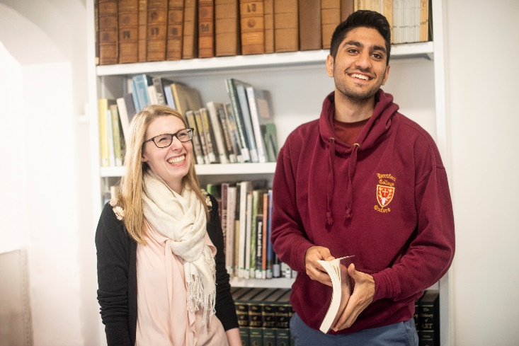

Our college library is a pretty central part of Hertford life - open 24/7, you'll always find someone there, whether they're preparing an essay, doing some revision, or just looking for the cat! Every Oxford college has a library for its own students, where most of your core texts will be available to borrow, and Hertford is no different. There are more than 50,000 books in the library collection (with another 5,000 rare and historic books) and our wonderful Librarian, Alice, is always willing to buy new books if they're on your reading list. Whilst any student can access the University's central Bodleian Library (just over the road from Hertford) and faculty libraries, it's great to have the college library as a base. Our's is friendly, relaxed, and super handy if you live on the main site. The ever-expanding collections of the college library and Bodleian mean that you're unlikely to have to spend loads of money on textbooks (which are surprisingly expensive)! The fact that our library is open 24/7 and has self-service borrowing with no limits makes it amazingly convenient - you can borrow and return books whenever you like and work there for as long as you need.
Alice, our amazing Librarian.
Simpkin in his favourite spot.
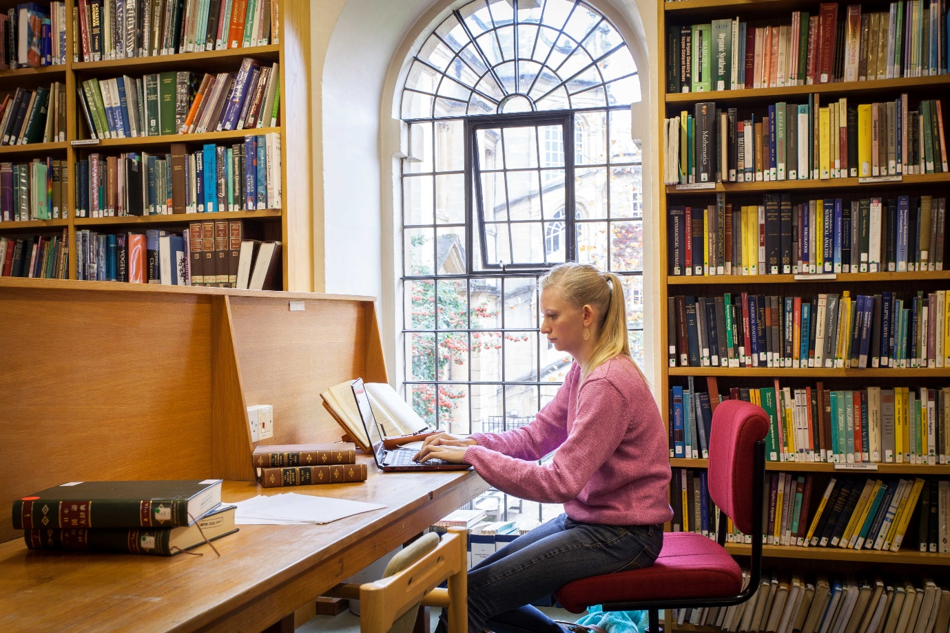

A day in the life
According to Jaya (English, 1st year)
08:30 – Wake up and try to convince myself to go to that 9am lecture… (though sometimes hitting snooze and falling back to sleep is just too tempting an offer to refuse)! In general, humanities students have fewer contact hours than scientists who need to be in the lab, so our schedules are more flexible.
09:05 - Made it to the lecture in the nick of time (a quirk of Oxford is that most lectures start at 5 past the hour, giving you a precious few minutes to play with!).
10:00 – After the lecture I’ll head back to college from the English Faculty and go to the on-site gym – no excuse not to go when it’s downstairs!
11:15 – Shower, get ready and head to the Bodleian Library or the Rad Cam which are both wonderfully nearby, right opposite college. Here I’ll spend about two hours doing the reading for my next tutorial or writing an essay... it really depends on the day.
13:15 – Meet some friends for lunch or coffee at one of the many places around town – be it the beautiful Vaults & Gardens, one of the chain restaurants on George Street, or one of
of the pretty little cafés on the High Street. But if I just fancy something quick and cheap I’ ll pop back to college and eat in hall, where the food is great and you’ll bump into all your college friends!
14:30 – Sometimes I'll have a tutorial or a class for an hour or so, leaving the rest of the afternoon to do as I please, depending on what my workload looks like for the rest of the week.
15:45 – I head back to the Rad Cam to prep for a class tomorrow - I'm very pleased to see that my desk from this morning is still available!
18: 00 – Work on one of my extra curriculars, be it writing an article for the Cherwell newspaper, going to a play rehearsal or attending a talk held by one of the many societies (I like Feminist Soc, Psychology Soc, the Oxford Union). There are so many extra curriculars on offer here that most people spend at least a couple hours a day doing one of them!
19: 15 – Sort out what I’ m going to have for dinner – if I've finished work earlier then I'll nip to Hall, otherwise there'll usually be some ingredients in my fridge and I will head down to the JCR kitchen.
20: 30 – If I am feeling particularly productive I might try and squeeze in an hour or two of work here, if not, I’ll probably watch something on Netflix in a friend's room or call friends from home.
22: 00 – Head DTB (the college bar) to catch up with friends – at this point the night can go one of two ways: either I responsibly head up to bed in an hour or two… or I get talked into going on a night out with friends. It can really swing either way!
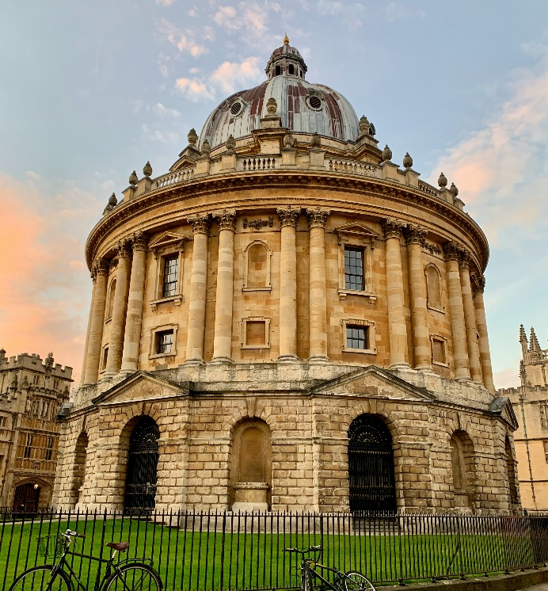


The Rad Cam
…or Radcliffe Camera, to give it its proper name, is a library and arguably the most beautiful building in Oxford. You can see it from Hertford’s dining hall because it’s just over the road, making it the perfect spot to catch up with some reading if you want a change of scenery from the college library. It technically the History Faculty Library but don’t let that put you off – you don’t have to be studying History to use it!

“Ooh, heaven is a place on earth”
Sang Belinda Carlisle in 1987 - it turns out she was talking about Hertford College
At Hertford, we’re all incredibly proud to be one of the most progressive and supportive colleges in Oxford. In recent years we’ve also become one of the colleges with the biggest LGBTQ+ community: we may be small, but we like to think we’re a force to be reckoned with. As a community, we organise lots of socials (including alcohol-free ones!) in college, as well as participating in University-wide events. Our local LGBTQ + bar’ s student night is Tuesday, and every Tuesgay you’re sure to spot the Hertford lot gathering like a twack of ducks (yes, that’s the official term). The LGBTQ+ community at Hertford and across Oxford is really strong and supportive. We’re of all backgrounds and ages, and as a baby gay myself I know how encouraging it is to meet someone who’s gone through the same things you have and come out the other side - as well as someone who knows the dos and don’ts of Oxford gay clubbing. There are plenty of older years who will happily take any freshers under their wing. We’re one big, gay, happy family and we’re thrilled to see our family grow!

Hannah, JCR LGBTQ+ Rep (Physics, 1st year)
Oxford Pride.

Equal opportunities
As one of the first colleges to become co-educational in the 1970s, and the first college to admit a black Rhodes Scholar, we pride ourselves on continuing the fight for more representative student body. Whatever your background, you will feel represented, accepted, and proud here. Every year we elect a new committee of student reps, headed by the Equal Opportunities President. These reps(for students who identify as BME, working class, disabled, LGBTQ+ or women) organise events for everyone and are there to support you with any worries you might have. The Equal Opportunities Committee also run the college Equalities Week every year. This is a celebration of diversity at Hertford, but also a way to look at how we can work to be a more inclusive environment for everyone. We're also lucky to have a Tutor for Equality & Diversity who's there to represent and advocate for inclusive culture at the highest levels of college.

Black, Asian & minority ethnic students
Our diverse community of BME students play an active role in college life, organising events for everyone at Hertford. We like to celebrate diversity in academia through events such as BME Formals and cultural fairs. We also think about the future and celebrate diversity in the careers sector by organising for BME speakers to talk at the college. A large proportion of our BME students get involved in access and outreach activities too, regularly helping with Q&A sessions and often doing visits to schools in the Oxfordshire area with large numbers of BME pupils, helping to inspire the next generation of students.
Back in the 1960s, Hertford pioneered access to Oxford for students from state schools and colleges. This work continues today, ensuring that Hertford is a welcoming and accessible place for those from under-represented backgrounds. Today, 70% of our UK students come from state schools - the second highest figure in the whole University. Our Student Ambassadors play a huge role, speaking to school groups and giving college tours, and helping with Open Days and interviews. It's a great way to get involved with the college, get to know other years, and feel like you're doing some good.

Caleb, JCR BME Rep (Biology, 1st year)
Enjoying a BME formal dinner. Photo © Michael-Akolade Ayodeji.

Did you know?
Back in the 1960s, Hertford pioneered access to Oxford for students from state schools and colleges. This work continues today, ensuring that Hertford is a welcoming and accessible place for those from under-represented backgrounds. Today, 70% of our UK students come from state schools - the second highest figure in the whole University. Our Student Ambassadors play a huge role, speaking to school groups and giving college tours, and helping with Open Days and interviews. It's a great way to get involved with the college, get to know other years, and feel like you're doing some good.

Check out our 2019 Equalities Week Portrait Gallery at www.hertford.ox.ac.uk/portrait
Photo by Ebrubaoghene Ayovunefe.

Wonderful world of wellbeing
It’s virtually impossible to spend time in college and not bump into a friendly face - we're famous for our fun, friendly and welcoming atmosphere. Here, students’ wellbeing is important to everyone. College has a great wellbeing system to help with any issues you may have at university, whatever they're about.
The wellbeing team maintains a high profile in college, so students know that if problems arise, or if they're just feeling a little blue, there are people around who are very happy to chat. We're lucky to have a professional Welfare & Wellbeing Coordinator, trained Peer Supporters, an on-site Nurse, the Chaplain, four Junior Deans (graduate students on call 24/7) and student Welfare Officers, elected by their fellow students.
The Welfare Officers raid the supermarket to buy snacks for Wellbeing Teas, where everyone can come and eat food, drink tea and have a catch-up in the JCR! They also give out free welfare supplies and occasionally organise speaker events. Ultimately, the most important part of the role, as peer supporters, is to be there to listen and help with any social, academic, financial or health problems you may have (oh, and obviously to make a world class cup of tea).
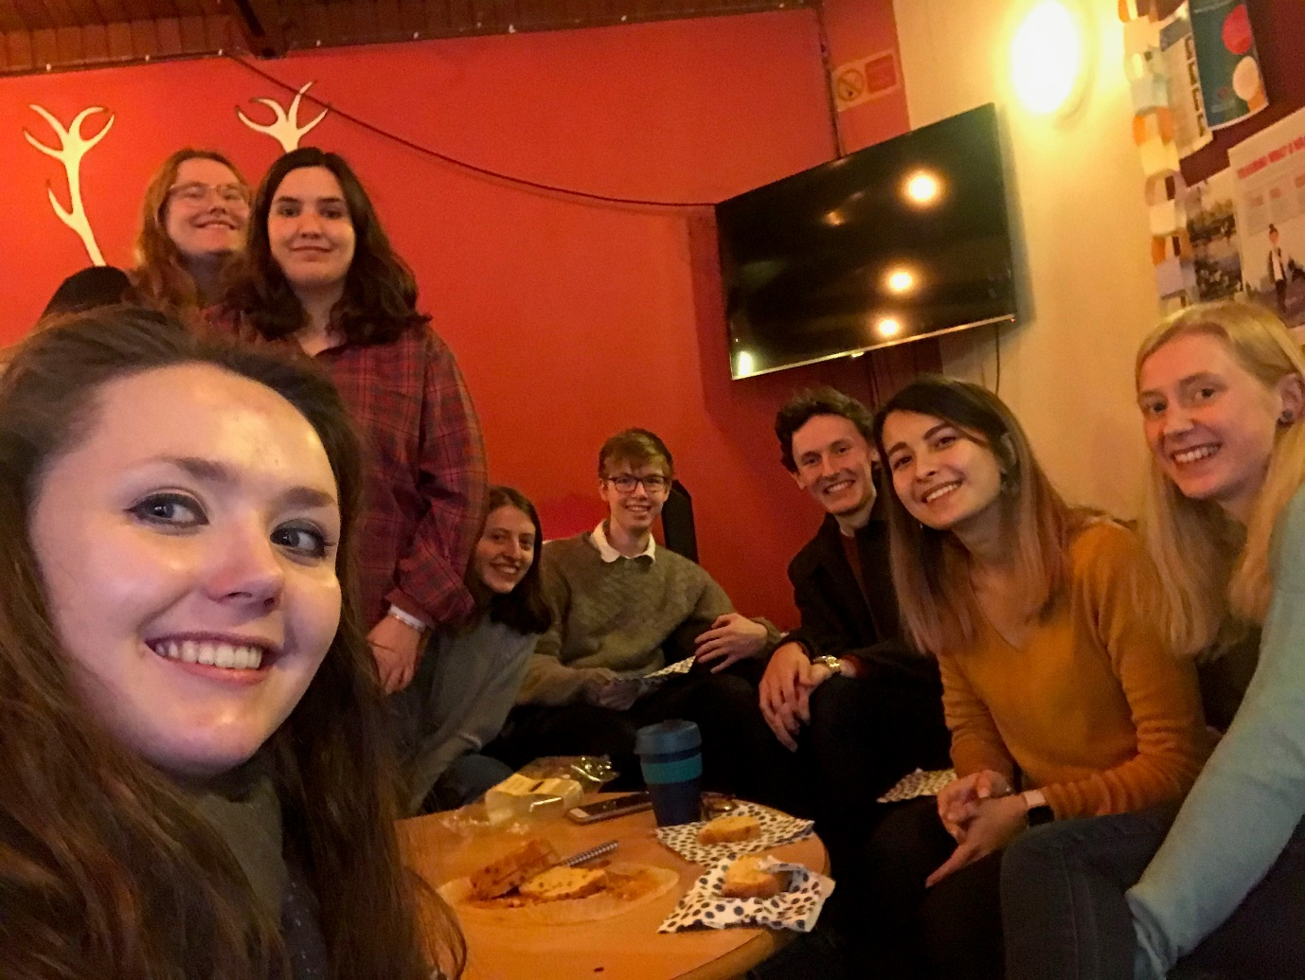
Rory & Susie, JCR Welfare Officers (Biochemistry / Biology, 2nd years)

"As Chaplain, I am part of our big, wonderful wellbeing team, which offers 24/7 support to the Hertford community. We want nothing to get in the way of you being and doing your best during your time with us, so I’m available for confidential chats (often with cake on the side!) about life, relationships, work, stress, faith, or anything else. As a former nurse and midwife, there’s little I haven’t seen or heard before when it comes to wellbeing, so I want to offer a safe and supportive space for our students.
I'm also an Anglican priest and, with an enthusiastic student team, I lead services in the Chapel. Our fantastic choir sing traditional Choral Evensong every Sunday in term, and lots more too! We never lock the Chapel, so it's a great place to come and sit quietly, read a book, pray, or practise music with a wonderful acoustic. Our events and services are open and welcoming to people of all faiths and none. Working together, we make sure that the needs of students of different faiths are met — from food and festivals, to finding places of worship."
Rev. Mia Smith, College Chaplain
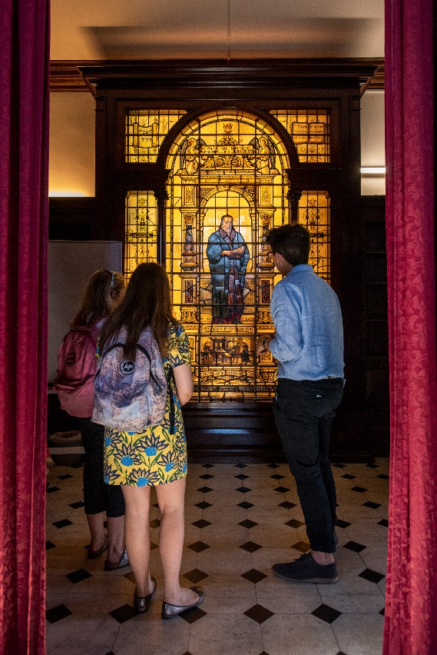
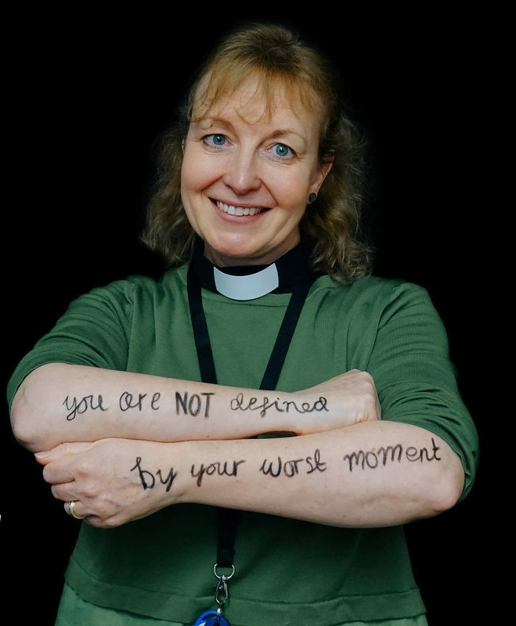
Mia, our lovely Chaplain.
…and the equally lovely Chapel, feat. Impressive light-up stained glass!

Faith matters
At Hertford, we really value people of faith and love the diversity you bring to our community. Our Chaplain, Mia, is always happy to work with students of any faith and to support them in their journey. People of any faith or none are welcome to use the Chapel as a prayer or meditation space and there is also a separate multi-faith prayer room on the main college site. Check out the Oxford SU guides for students of different faiths on their website: www.oxfordsu.org/activities/student-projects/a-place-for-you

Find out more…
- Website: www.hertford.ox.ac.uk
- YouTube: https://www.youtube.com/channel/UCPoIx90fwUNb_NsLLKVfB-g/
- Instagram: @hertfordcollege
- Instagram: @humansofhertford
- Twitter: @hertfordcollege
- Medium: www.medium.com/hertford-college

